Tuesday 25th October: 14.30-17.30
HOTS Simulation Train-the Trainer Workshop
Facilitators: Philip Marston and Michael James
In case you have questions about the workshop: info@russellpartnership.tech
In case you wish to register for the workshop: eurochriebudapest@wecotravel.hu
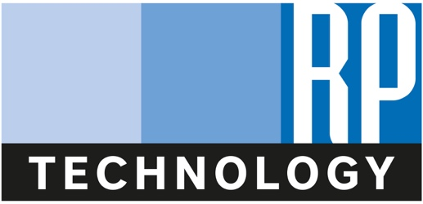
We produce industry leading simulation programs for the hospitality, restaurant and tourism industries. We license our products for educational use and deliver industry training and events. Our hotel simulation program, HOTS, is utilised by education and industry to teach and develop skills relating to operations, revenue management, benchmarking and more.
The HOTS Simulation Train-the-Trainer session will feature an update to the new version of HOTS and introduce how the simulation can be used to deliver revenue management specific courses. This session should be attended by both current and prospective users and will include hands-on practice with HOTS.

