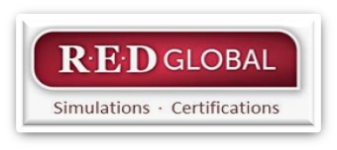
Wednesday 26th October: 9.30-11.30
Room F 203 (Main building – 1st floor)

REDGlobal: Using New Generation Simulations for New Generation Students in a New Generation Marketplace

Facilitators: Peter Starks and Heidi Anaya
Email: pstarks@triad.rr.com; heidioco@gmail.com

The REDGlobal Foundation provides hospitality business simulations, on a “not-for-profit” basis, as a service to educators, students, and institutions as our global “give-back” for the preparation of future industry leaders.
Delivered in over 40 countries, 8 languages, and 10 currencies, new-generation simulations are valued by over 6000 undergraduate and graduate students annually, elevating student engagement, embedding real-to-life learning, and enriching the enjoyment of teaching. They are internet delivered, industry validated, aligned with STR metrics, and grounded in reputation management for social media. Used by hospitality companies and institutions around the globe, new generations simulations help instructors bring real-world learning into class.
Peter and Heidi warmly welcome you to this non-commercial, interactive, and lively workshop, providing the following take-ways for educators who already use simulations and for those considering it. More information here - http://redglobal.articulate-online.com/6351575953

