Thursday 27th October: 14.15-15.45
Room F203
ICHRIE Johnson & Wales Case Study Competition & Journal of Hospitality & Tourism Cases: writing & using case studies
Facilitator: Dr Marianna Sigala (University of South Australia)
In case you have questions about the workshop: Marianna.Sigala@unisa.edu.au
In case you wish to register for the workshop: eurochriebudapest@wecotravel.hu

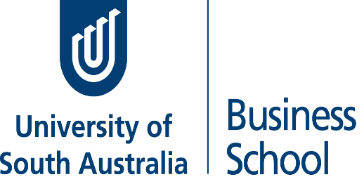
The workshop aims to ‘train’, guide and motivate scholars to develop, write and use case studies for educational purposes. The workshop will reveal insights from the I-CHRIE Johnson & Wales Case Study Competition and the Journal of Hospitality & Tourism Cases. Pedagogical strategies for integrating case studies into instructional methods will also be presented.

